Name: Shriya Ramya Mohan Exp No: 3
Roll no: 241901106

STUDY THE DIFFERENT TYPES OF NETWORK CABLES AND CRIMPING OF CABLES WITH RJ45 CONNECTOR

AIM:
To study the different types of network cables and crimping of cables with RJ45 connector.

THEORY
RJ45 CONNECTOR:
RJ45 is an 8-pin connector used at the end of Ethernet UTP cables for networking.
It has 8 positions and 8 contacts (8P8C) that carry data signals.
RJ45 connectors follow colour-coding standards—T568A and T568B—for arranging the 8 wires of the UTP cable in a specific order for proper communication.

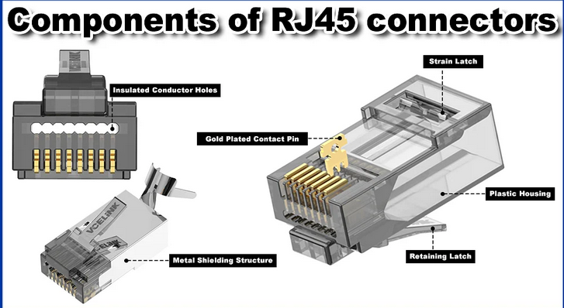

PROCEDURE:
- Cut the UTP cable to required length.
- Strip 1.5–2 cm of outer jacket using the stripper section of the crimping tool.
- Untwist the 4 pairs and straighten the 8 wires.
- Arrange the wires according to the required standard:
  - T568B for Straight-Through (both ends)
  - T568A on one end + T568B on other end for Cross-Over
- Hold the wires flat and trim them evenly with the cutter part of the crimping tool.
- Insert the wires into RJ45 connector (clip facing down).
Ensure:
  - Each wire sits in its correct slot
  - The colours remain in correct order
  - Wires reach the front tip of connector
- Place connector inside crimping slot of the tool.
- Press the crimping tool firmly to lock the wires into the connector.
- Repeat for the other end of the cable.
- Test the cable using a LAN tester or by connecting two devices.

RESULT
Cables were successfully prepared using UTP cable, RJ45 connectors, and a crimping tool, and their continuity was verified.

